Next are the conditions for implementing caching in a web application:

1. If you read data from external source than caching is not needed, otherwise it’s needed.
2. If data is readonly/readmostly then we need caching, otherwise not.
3. If the site performance is important then we’d better have caching.
4. If the data that is read is constant (not changing) then we’d better setup caching for it.

Below is activity diagram of the aforementioned.

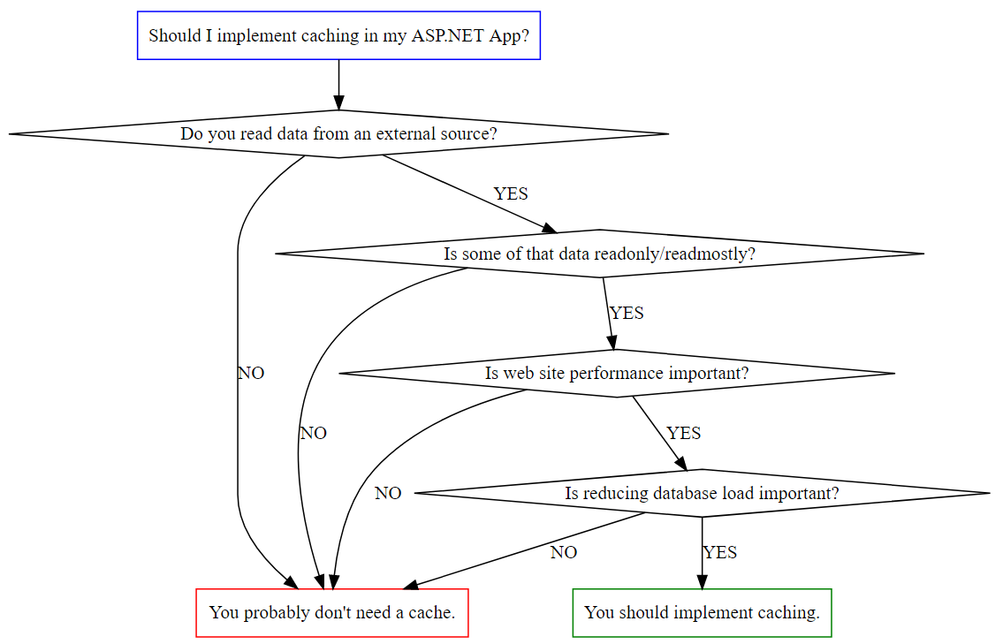

The author of this diagram is Steve Smith, from his blog - <https://ardalis.com/should-i-add-caching-to-my-web-application>

**Homework:**

Next is activity diagram for the login activity in a site. Try to fully understand it first. Try to describe it with your own words.

